 | Dedicated:  Journal of Community Services  (Pengabdian kepada Masyarakat)  https://ejournal-education.upi.edu/dedicated | 

Green Energy Bank: Pioneering energy independence in Wiyata Tech Village, Purwakarta

Muhammad Rizalul Wahid¹, Mahmudah Salwa Gianti², Zaldi Arifa³
^{1,2,3} Universitas Pendidikan Indonesia, Purwakarta, Indonesia
rizalulwahid@upi.edu¹, msg.salwa@upi.edu², zaldiarifa@upi.edu³

ABSTRACT |  | ARTICLE INFO
Indonesia targets a renewable energy mix of 23% by 2025 under the National Energy Policy (KEN). However, Kutamanah Village in Purwakarta Regency, despite an average solar radiation of 1,402.7 kWh/kWp per year, still lacks reliable public lighting and faces high energy costs because of limited infrastructure, technology access, and community economic capacity. This community service program addressed that gap by designing, assembling, and installing a centralized Green Energy Bank consisting of a 300 Wp photovoltaic array, an MPPT charge controller, and a 1.2 kWh lithium-ion battery bank to supply the village security post and public charging needs, implemented through a five-stage method spanning preparation, technical design, socialization, field installation, and evaluation. Engineering validation confirmed stable overnight power delivery, while a satisfaction survey of ten beneficiary residents conducted one month after commissioning showed that 90% rated the electricity supply as sufficient to highly sufficient, 100% reported improved night security, and 90% supported replication at other public facilities. These results indicate that the integrated solar-battery model is technically reliable and socially accepted, positioning Kutamanah Village as a replicable pioneer of renewable energy-based, energy-independent villages that supports SDG 7, SDG 11, and SDG 13. |  | Article History:  Received: 12 Apr 2026  Revised: 22 Aug  Accepted: 30 Aug 2026  Publish online: 27 Sep 2026
Keywords:
energy-independent village; Green Energy Bank; solar panel; Wiyata Tech

Open access 
Dedicated: Journal of Community Services (Pengabdian kepada Masyarakat) is a peer-reviewed open-access journal
ABSTRAK
Indonesia menargetkan bauran energi terbarukan sebesar 23% pada tahun 2025 sesuai Kebijakan Energi Nasional (KEN), namun Desa Kutamanah di Kabupaten Purwakarta, meski memiliki rata-rata radiasi surya 1.402,7 kWh/kWp per tahun, masih kekurangan penerangan umum yang andal dan menghadapi biaya energi yang tinggi akibat keterbatasan infrastruktur, akses teknologi, serta kapasitas ekonomi masyarakat. Program pengabdian ini menjawab kesenjangan tersebut melalui perancangan, perakitan, dan pemasangan Bank Energi Hijau terpusat yang terdiri atas panel surya 300 Wp, pengontrol pengisian MPPT, dan baterai lithium-ion 1,2 kWh untuk memenuhi kebutuhan pos keamanan desa serta pengisian daya publik. Program ini dilaksanakan melalui metode lima tahap, meliputi persiapan, perancangan teknis, sosialisasi, instalasi di lapangan, dan evaluasi. Validasi teknis menunjukkan kestabilan pasokan daya pada malam hari, sementara survei kepuasan terhadap sepuluh warga penerima manfaat, satu bulan setelah commissioning, menunjukkan bahwa 90% menilai pasokan listrik cukup hingga sangat cukup, 100% melaporkan peningkatan keamanan pada malam hari, dan 90% mendukung replikasi di fasilitas publik lainnya. Hasil ini menunjukkan bahwa model panel surya-baterai terintegrasi ini andal secara teknis dan diterima secara sosial, menjadikan Desa Kutamanah sebagai pionir desa mandiri energi berbasis energi terbarukan yang dapat direplikasi serta mendukung SDG 7, SDG 11, dan SDG 13.
Kata Kunci: Bank Energi Hijau; desa mandiri energi; panel surya; Wiyata Tech

How to cite (APA 7)
Wahid, M. R., Gianti, M. S., & Arifa, Z. (2026). Green Energy Bank: Pioneering energy independence in Wiyata Tech Village, Purwakarta. Dedicated: Journal of Community Services (Pengabdian kepada Masyarakat), 4(2), 391-404.
Peer review
This article has been peer-reviewed through the journal’s standard double-blind peer review, where both the reviewers and authors are anonymised during review.
Copyright
2026, Muhammad Rizalul Wahid, Mahmudah Salwa Gianti, Zaldi Arifa. This an open-access is article distributed under the terms of the Creative Commons Attribution-ShareAlike 4.0 International (CC BY-SA 4.0) https://creativecommons.org/licenses/by-sa/4.0/, which permits unrestricted use, distribution, and reproduction in any medium, provided the original author, and source are credited. *Corresponding author: zaldiarifa@upi.edu

INTRODUCTION
At the national level, Indonesia has set an ambitious target to achieve a 23% renewable energy mix by 2025, as mandated by the National Energy Policy (Kebijakan Energi Nasional or KEN). This strategic target is firmly anchored in a robust regulatory framework, including Undang-Undang Nomor 30 Tahun 2007 tentang Energy and Peraturan Pemerintah Nomor 79 Tahun 2014 tentang Kebijakan Energi Nasional (see: https://www.esdm.go.id), both of which actively accelerate the deployment and utilization of New and Renewable Energy (NRE) throughout the archipelago (Silalahi et al., 2021). Aligning with this national agenda, the implementation of the community service project titled “Green Energy Bank in Wiyata Tech Village: Pioneer of Energy-Independent Village in Purwakarta Regency” serves as a localized catalyst to support state-level transitions toward sustainable infrastructure.
Furthermore, this initiative directly intersects with the United Nations Sustainable Development Goals (SDGs), primarily SDG 7: Clean and Affordable Energy, which seeks to guarantee universal access to affordable, reliable, and modern energy services. It also addresses SDG 11: Sustainable Cities and Communities by strengthening rural security infrastructure and SDG 13: Climate Action by directly reducing carbon footprints. Locally, this intervention translates these global ideals into the “Village SDGs” paradigm, specifically fostering Clean and Renewable Energy Villages alongside Sustainable Rural Infrastructure and Connectivity (see: https://sdgsdesa.kemendesa.go.id).
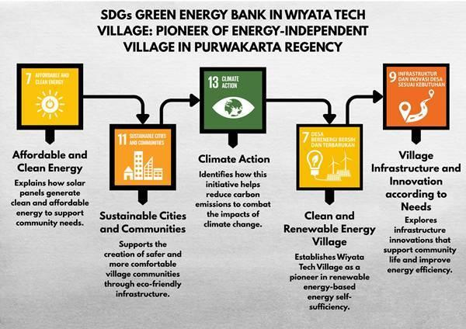

Figure 1. United Nations Sustainable Development Goals Supported by the Green Energy Bank Program
Source: Author Documentation 2026

Figure 1 illustrates the three SDG targets, SDG 7, SDG 11, and SDG 13, that are directly addressed by the Green Energy Bank program, linking the intervention's technical outputs to Indonesia's national and village-level sustainability commitments. Solar-powered public street lighting has become a widely replicated community service intervention across rural Indonesia. However, a review of prior initiatives reveals a persistent gap that this program seeks to close. Several previous community service activities, such as the installation of solar-powered public lighting in Puncak Anabawa, Rokan Hulu, and in Seuseupan Village, Sukabumi, focused primarily on single-unit lamp installation without a centralized, sized energy-storage architecture, so continuity of supply during consecutive overcast days was not systematically addressed (Negara et al., 2026; Sinurat et al., 2023). Community-based photovoltaic training programs, such as the grid-tie PLTS operation and maintenance training in Gunung Kidul and the community-based photovoltaic initiative toward an energy-independent village in Wonosalam, emphasized technology transfer and feasibility studies but did not report a formal institutional partnership with a regional development planning agency or a structured post-installation satisfaction evaluation (Kusuma et al., 2023; Wahyuni et al., 2020).
Likewise, the photovoltaic irrigation program in Jatirejo Cepu and the solar-powered lighting program in Desa Rabak demonstrated the technical feasibility of decentralized solar applications but did not integrate a high-capacity lithium-ion battery bank engineered against a quantified daily watt-hour demand (Sari et al., 2023; Wardhana et al., 2023). Earlier related interventions reinforce this pattern: solar cell street-light installations along Jl. Giri Rejo and photovoltaic-based aquaponics electrification in Tanjung Palas prioritized single-application electrification without a sized storage architecture, while photovoltaic electrification of communal facilities such as the AT-Taubah Musholla and residential lighting in Petukangan Utara similarly stopped short of a centralized, load-calculated battery bank; earlier feasibility and benefit-oriented studies of village-scale solar deployment likewise did not couple technical installation with a formal institutional partnership or a structured post-installation evaluation (Agustina et al., 2025; Demeianto et al., 2021; Ismangil et al., 2024; Laksana et al., 2021; Prabowo et al., 2020; Yuwono et al., 2021).
Building on these precedents, the novelty of the present program lies in its combination of 1) A centralized, load-calculated 300 Wp-1.2 kWh solar-battery architecture housed in a dedicated Energy Box; 2) A formal Memorandum of Understanding with BAPPERIDA Purwakarta Regency to embed the intervention within regional development planning; and 3) A structured community satisfaction evaluation conducted one month after commissioning an integration that has not been jointly demonstrated in the previous studies reviewed above. Kutamanah Village, in the Sukasari District of Purwakarta Regency, offers strong geographical advantages for solar energy cultivation due to high, uninterrupted solar irradiance year-round. However, despite this promising renewable resource base, the village has long suffered from infrastructural stagnation and severe technological disparities, leaving its solar potential largely untapped. This technological gap is severely compounded by the low economic status of the local populace, for whom conventional electricity costs pose an ongoing financial strain.
Consequently, critical community needs such as reliable public night lighting and public electronic device charging hubs remain largely unfulfilled for a significant portion of the inhabitants (Aditya & Harahap, 2024; Andre et al., 2024; Hadiyanto et al., 2021; Hazrina et al., 2024; Jusuf et al., 2024). The lack of localized energy architecture also impedes autonomous community development; minimal exposure to renewable technology, restricted information networks, and low technical human resource capacity collectively trap the village in a state of energy vulnerability (Fathoni et al., 2021). According to data from the Global Solar Atlas, Kutamanah Village has an average specific solar radiation of 1,402.7 kWh/kWp per year, confirming its status as an optimal candidate for sustainable photovoltaic engineering (see: https://globalsolaratlas.info). This community service program deployed a centralized solar panel framework designed to reliably absorb daily solar yields and provide free, sustainable electricity to address these multi-layered issues.
The technical architecture integrates high-efficiency photovoltaic modules with a localized, high-capacity lithium-ion battery bank housed within a specialized “Energy Box” system. This centralized model guarantees a steady electricity supply to the village’s main public security post (pos kamling), ensuring community safety through consistent night illumination. Additionally, the unit serves as a public micro-grid hub where residents can freely charge essential communication devices, flashlights, and portable equipment. Beyond offering immediate socioeconomic relief, this framework establishes a scalable, replicable model that supports national carbon-reduction targets while cultivating grassroots energy autonomy, consistent with recommended sizing and optimization practices for off-grid rural energy storage systems (Soomro et al., 2026).
Therefore, the core community service and implementation questions guiding this program are defined as follows: 1) How effective is the deployment of a centralized solar-powered Green Energy Bank system with advanced battery storage in mitigating the community’s immediate public electrical constraints?; 2) How do technological adaptation, institutional alignment, and local community participation converge to establish Kutamanah Village as a baseline pioneer for energy-independent rural settlements? In response, this project aims to provide a functional pilot of a self-sustaining rural energy ecosystem that strengthens social, economic, and safety dynamics, reduces systemic reliance on the conventional national grid (PLN), and eases household economic strain. By embedding active local participation in operations and maintenance, the program aims to build local technical capacity and establish collective ownership.

METHODS
This community service project was carried out in Kutamanah Village, a rural locality in the Sukasari District of Purwakarta Regency. Sukasari District covers 92.01 km² and comprises 5 villages, with Kutamanah Village covering 30.1 km². The spatial target for the technical intervention focused on the main neighborhood public security hub (pos kamling) and surrounding community gathering zones, which historically lacked stable, continuous access to the national electrical grid.
Table 1. Geographical Area Data of Kutamanah Village, Sukasari District

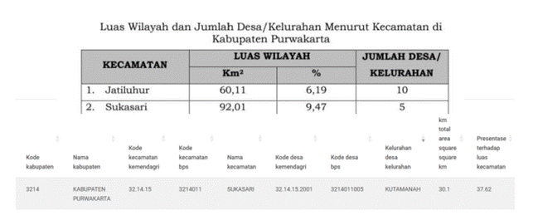
Source: Author Documentation 2026

As shown in Table 1, Kutamanah Village occupies roughly one-third of Sukasari District's total land area, an administrative scale that helps explain the logistical spread of the electrification target zones described above.

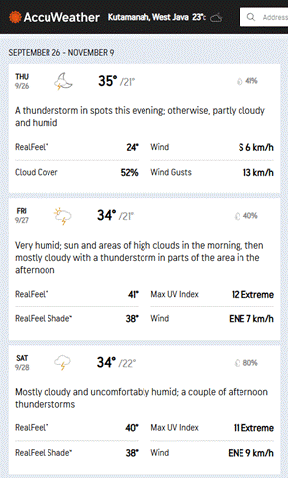

Figure 2. Temperature and Weather Data of Kutamanah Village
Source: Author Documentation 2026

Figure 2 presents the recorded temperature and weather profile of the site, indicating consistently high solar heat exposure and low precipitation, both of which support sustained photovoltaic energy yield throughout the year.
Table 2. Population Census of Sukasari District, 2020

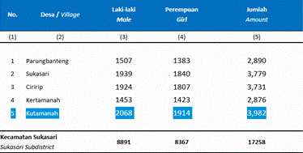
Source: https://purwakartakab.bps.go.id 2026

As reported in Table 2, Sukasari District recorded a total population of 3,982 residents, with a fairly balanced gender distribution, indicating a sufficiently large beneficiary base to justify a centralized rather than single-household energy solution (see: https://purwakartakab.bps.go.id). The operational methodology was executed through five strictly sequenced phases:

Preparation Phase
The initial phase involved formalizing the task force, which comprised a project leader, implementation team members, and a dedicated field evaluation unit. The team conducted systematic field surveys and problem mapping, followed by intensive coordination meetings with Kutamanah’s village administrators and community elders. Solar resource verification indicated that the site yields a specific photovoltaic power output of 1,463.8 kWh/kWp per year, representing peak localized radiation within Purwakarta. Simultaneously, a formal Memorandum of Understanding (MoU) was established between the UPI Purwakarta Campus task force and the regional planning agency, BAPPERIDA Purwakarta Regency, to ensure absolute alignment with local regional development blueprints.
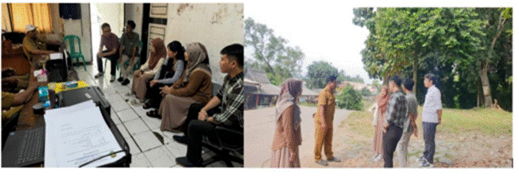

Figure 3. Community Service Location Survey Activity
Source: Author Documentation 2026

Figure 3 documents the joint field survey conducted by the implementation team and village stakeholders to verify candidate installation points and confirm unmet electrification needs prior to technical design.
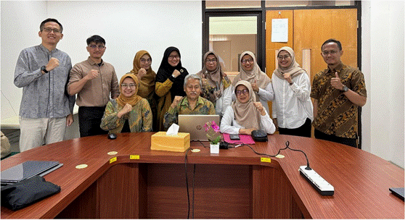

Figure 4. BAPPERIDA Collaboration with UPI Purwakarta
Source: Author Documentation 2026

Figure 4 depicts the formal signing of the Memorandum of Understanding between the UPI Purwakarta Campus team and BAPPERIDA Purwakarta Regency, which anchored the program within the regency's regional development planning framework.

Technical Design and Assembly Phase
The engineering team conceptualized and calculated the Green Energy Bank's technical specifications. This process included sizing the solar photovoltaic arrays, deploying two 150 Wp solar panels to achieve a total capacity of 300 Wp. The team integrated a 10A Maximum Power Point Tracking (MPPT) Smart Charge Controller and a 1200 W power inverter to safely manage the electrical loads. For energy storage, the team selected and calibrated a high-capacity 1.2 kWh lithium-ion battery bank against the community’s projected daily public watt-hour consumption. This technical configuration delivers a highly reliable impact for the village micro-grid. Under optimal localized solar radiation, the 300 Wp array requires about 4 to 5 hours of peak sunshine to charge the 1.2 kWh battery bank fully. Once fully charged, the system’s storage capacity can comfortably sustain the public security post’s essential amenities, such as energy-efficient LED night illumination and mobile device charging hubs, for over 24 hours of autonomous operation, ensuring continuous service even during overcast periods. The team conducted pre-assembly and rigorous control-loop testing in campus laboratory facilities before field deployment to validate these parameters.
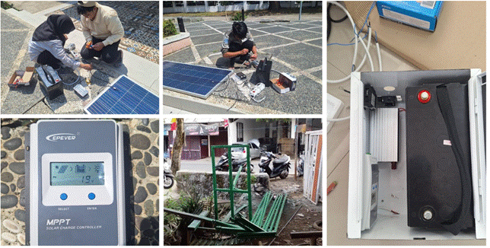
Figure 5. Energy Bank Assembly Activity
Source: Author Documentation 2026

Figure 5 shows the campus-based assembly of the photovoltaic array, charge controller, inverter, and lithium-ion battery bank into the Energy Box enclosure prior to field deployment.

Socialization and Community Training Phase
To safeguard long-term sustainability, the team conducted structured socialization workshops detailing the Green Energy Bank's operational mechanisms, essential system controls, troubleshooting workflows, preventive maintenance routines, and the environmental science behind solar power. Residents and village youth leaders took part in hands-on demonstrations, learning how to interpret battery charge-status displays and safely clean solar module glass surfaces.
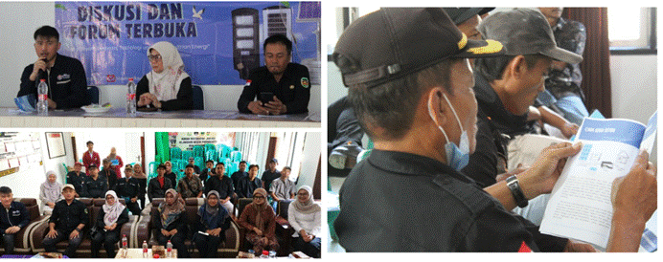
Figure 6. Socialization Process
Source: Author Documentation 2026

Figure 6 captures the socialization session in which residents and youth leaders received hands-on training in system operation and maintenance before installation.

Field Installation Phase
The physical deployment of the solar array supports and the protective “Energy Box” enclosure was completed through a collaborative communal effort at the target site. Mechanical mounts were structurally reinforced and anchored to ensure optimal tilt orientation, stability, and long-term wind resistance.
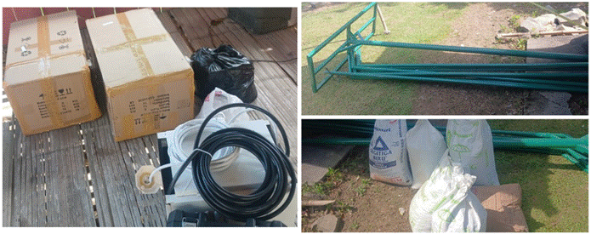

Figure 7. Lowering of PJU Lamps and Supporting Materials
Source: Author Documentation 2026

Figure 7 shows the preparatory step of lowering existing lamp poles and staging supporting materials such as cement and soil ahead of the foundation work.
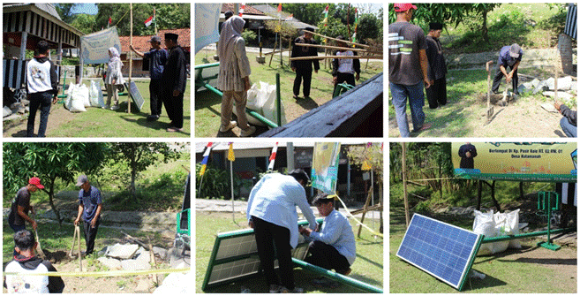

Figure 8. Green Energy Bank Installation Process
Source: Author Documentation 2026

Figure 8 illustrates community members participating in soil excavation and concrete pouring, the main structural foundation step of the installation.

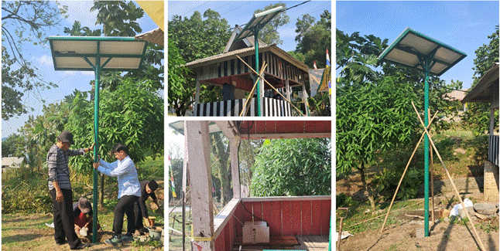

Figure 9. Green Energy Bank Installation Process Ensuring a Sturdy and Stable Upright Position
Source: Author Documentation 2026

Figure 9 confirms the final verification step, in which the team checked the pole's verticality and structural stability before handing the unit over for community use.

Evaluation and Validation Phase
The team validated system performance metrics through real-time telemetry testing across varying weather conditions. The team gathered social impact metrics through comprehensive community satisfaction surveys administered to beneficiary representatives after one month of continuous field operation.

RESULTS AND DISCUSSION
This section presents results from each of the five implementation stages described in the Methods section, followed by engineering validation outcomes, the community satisfaction survey, the challenges encountered, and the program's sustainability outlook.

Outcomes of the Program Implementation Stages
The Preparation Phase produced two concrete outputs: a signed Memorandum of Understanding with BAPPERIDA Purwakarta Regency and a confirmed solar resource assessment of 1,463.8 kWh/kWp per year at the chosen site. The Technical Design and Assembly Phase produced a fully assembled, laboratory-tested 300 Wp solar array paired with a 1.2 kWh lithium-ion battery bank, sized to sustain the security post's LED lighting and charging load for more than 24 hours per full charge. The Socialization and Community Training Phase reached residents and village youth leaders through hands-on workshops on system operation, troubleshooting, and panel maintenance. The Field Installation Phase was completed collaboratively with community members, resulting in a structurally verified, upright, and operational Green Energy Bank unit at the target security post. These stage-level outputs collectively formed the basis for the engineering validation and social impact evaluation reported below. This convergence aligns with community empowerment models that link solar-energy-based interventions to the development of energy-smart villages and improved local welfare (Hadi et al., 2025).
Engineering Validation and Technical System Performance
Before transferring complete operational control to the community, the Green Energy Bank underwent intensive engineering validation. The rooftop photovoltaic array, smart solar charge controller, and lithium-ion storage bank integrated structurally and operated within safe parameters. The system effectively harvested solar energy during peak sunshine hours and stored it safely inside the specialized Energy Box. Empirical tests on low-light and heavily overcast days confirmed that the lithium-ion cell-balancing algorithms maintained sufficient depth-of-discharge levels, sustaining the public post’s LED security lights and mobile charging stations overnight without power interruptions. This performance aligns with adaptive solar-panel control strategies previously piloted in the same Wiyata Tech Village setting and with evaluation and modeling approaches that link photovoltaic system sizing to actual green-energy consumption patterns (Napitupulu et al., 2024; Wahid et al., 2025). The stability of the observed harvest levels is further supported by clustering-based assessments of solar irradiation and temperature attributes used for tropical photovoltaic site selection and by irradiance-estimation modeling for tropical regions, both of which corroborate Kutamanah Village’s suitability as a high-yield deployment site (Suwadana et al., 2025; Tanoto et al., 2024).

Social Impact and Community Satisfaction Metrics
One month after field commissioning, we administered a random-sample survey to 10 active residents of Kutamanah Village to evaluate localized social impact. The psychometric survey explored five core assessment metrics, with tabulated response breakdowns displayed in Table 3.

Table 3. Community Satisfaction Survey Results (n = 10)

No | Evaluation Assessment Metric | Response Metrics and Percentage Breakdown (%)
1 | Were you previously aware of renewable solar energy technologies using photovoltaic panels? | Yes: 70% | No: 30%
2 | Does the Green Energy Bank supply enough electricity to meet the neighborhood security post's needs? | Highly Sufficient: 30% | Sufficient: 60% | Insufficient: 10%
3 | Do you feel competent to operate and maintain the system after the training workshops? | Fully Understand: 60% | Moderately Understand: 30% | Do Not Understand: 10%
4 | Has the deployment of the Green Energy Bank measurably improved the security post's operational utility at night? | Highly Effective: 60% | Moderately Effective: 40% | Ineffective: 0%
5 | Do you agree that this Green Energy Bank framework is replicated for other public facilities (schools, houses of worship, etc.)? | Agree: 90% | Disagree: 10%
Source: Author Documentation

The empirical results in Table 3 demonstrate strong positive social acceptance. A combined 90% of respondents rated the public power yield as highly sufficient to sufficient for public safety functions, and 100% of the sample agreed that night watch routines had improved due to stable illumination. Knowledge absorption was also strong, with 90% of the community feeling confident in managing the unit's daily operations. Crucially, there is overwhelming consensus (90% agreement) to expand and replicate this micro-grid system in other local public buildings. These outcomes broadly align with, and in some respects exceed, findings from comparable community service initiatives elsewhere in Indonesia. The solar-powered public lighting program in Seuseupan Village, Sukabumi similarly reported a marked improvement in residents' sense of nighttime security following installation, consistent with the 100% improvement rate recorded in Kutamanah Village (Negara et al., 2026; Putra et al., 2026).
The community-based photovoltaic training program toward an energy-independent village in Wonosalam likewise found that hands-on socialization significantly increased residents' operational confidence, mirroring the 90% competency rate observed here (Wahyuni et al., 2020). However, several prior programs, such as the solar street lighting installation in Puncak Anabawa and in Desa Rabak, did not report a formal replication-intent metric comparable to the 90% agreement recorded in this study, suggesting that the combination of centralized battery storage and institutional MoU backing in the Green Energy Bank model may have strengthened residents' confidence in the program's long-term viability beyond what single-unit lighting interventions typically achieve (Anggraeni et al., 2023; Sinurat et al., 2023). This pattern is consistent with theoretical accounts linking renewable energy-based village electrification to measurable poverty reduction and improved household welfare in remote areas, and it echoes evidence that structured socialization and appropriate-technology training on solar cell systems substantially strengthen community operational competence (Rusdi et al., 2021; Wirawan & Gultom, 2021).

Encountered Systemic Challenges and Contextual Solutions
Throughout implementation, the task force noted several systemic challenges. These included initial community skepticism rooted in unfamiliarity with solar engineering and concerns about long-term maintenance costs. Geographically, the village’s remote location meant no fallback grid infrastructure was available. To address these issues, the team introduced an intensive, hands-on workshop approach that simplified operations for residents. The team reinforced this educational framework by officially creating a localized Energy Management Committee, whose members oversee routine system checks. Furthermore, the engineering team deliberately over-engineered the lithium-ion battery capacity to ensure the system can operate autonomously for extended periods, even during consecutive overcast days, without requiring grid support. The decision to formalize a dedicated Energy Management Committee aligns with theoretical models of community-based renewable energy regulation, which emphasize that clearly assigned local governance structures are essential for a just and durable transition to community-owned energy systems. At the same time, the deliberate over-engineering of storage capacity reflects broader resilience-oriented design principles recommended for off-grid installations operating under climatic uncertainty (Mahira & Karjoko, 2024) (see: https://rdiglobal.org/publications/view/10423/overview-of-renewable-energy-based-village-grids-rvgs-in-indonesia).

Strategic Sustainability and Future Action Plans
The long-term roadmap focuses on scaling up the socioeconomic benefits of this innovation while maintaining the newly established rural energy management structures. Future initiatives aim to strengthen strategic networks with regional government bodies, academic networks, and civil society groups. This collaborative approach will seek to replicate the Green Energy Bank architecture across other off-grid settlements in Sukasari District that require enhanced public lighting and communal power. Regular follow-up training sessions are planned to help maintain energy independence across the district. This financing and scale-up strategy is consistent with village-fund-based models of renewable energy development, which identify sustained local budget allocation and cross-institutional partnership as key enablers of long-term rural energy infrastructure (Marianti et al., 2023).

Limitations of the Community Service Activity
This community service activity has several limitations that should be considered when interpreting its outcomes. First, the satisfaction survey was administered to a small sample of ten residents at a single site, which limits the statistical generalizability of the results to Sukasari District or Purwakarta Regency as a whole. Second, the one-month post-commissioning evaluation period was too short to observe seasonal effects, such as extended overcast conditions during the rainy season, on the battery bank's autonomy and charging performance. Third, the program did not yet incorporate a remote monitoring system, so long-term degradation of the lithium-ion battery and photovoltaic output must currently be assessed through periodic manual inspection rather than continuous data logging. Fourth, the intervention was implemented at a single security post; multi-site deployment may reveal installation and maintenance challenges not captured in this pilot.
Future Community Service Directions
Building on the limitations identified above, subsequent community service activities are recommended to: (1) integrate a low-cost IoT-based remote monitoring module to log battery state-of-charge and panel output continuously across seasons, following the design storage sizing practices recommended for off-grid rural systems; (2) expand the beneficiary survey to a larger, multi-site sample across several hamlets within Sukasari District to strengthen the generalizability of satisfaction findings; (3) formalize a village-level maintenance regulation, co-developed with BAPPERIDA Purwakarta Regency, that assigns clear operational responsibility to a trained community task force; and (4) evaluate the long-term economic impact of the Green Energy Bank on household electricity expenditure over a full annual cycle, extending the single-month evaluation window used in this pilot (Soomro et al., 2026).

CONCLUSION
The deployment of the Green Energy Bank in Kutamanah Village has proven an effective, sustainable approach to addressing public energy deficits in remote areas by capitalizing on the village’s high solar yield of 1,402.7 kWh/kWp per year. The centralized system has provided a reliable power supply for night security and public charging hubs. Program evaluations indicate a clear improvement in public safety utility alongside a 90% community approval rating for future project expansion. With respect to the second research question, the convergence of technological adaptation, institutional alignment, and local community participation was central to establishing Kutamanah Village as a baseline pioneer for energy-independent rural settlements: hands-on training raised operational competence to 90%, the formal Memorandum of Understanding with BAPPERIDA Purwakarta embedded the intervention within regional development planning, and the newly formed Energy Management Committee institutionalized community ownership of the system. For long-term sustainability, the village administration should formalize the local management committee through clear village-level regulations. Additionally, the project team should continue working closely with BAPPERIDA Purwakarta to scale up this renewable energy infrastructure across Sukasari District systematically.

AUTHOR'S NOTE
The authors declare that there is no conflict of interest regarding the publication of this article. The authors also affirm that the data and content of this article are free from plagiarism. This community service program was funded by the Annual Work Plan and Budget Fund of the Universitas Pendidikan Indonesia (UPI) Campus in Purwakarta, Fiscal Year 2024, in accordance with Rector's Decree Number: 443/UN40/PT.01.02/2025.
REFERENCES
Aditya, L., & Harahap, A. R. (2024). Rancang bangun penerangan jalan umum untuk mengatasi kondisi berkabut menggunakan sensor LDR dan sensor kabut berbasis Esp 32. Jurnal Elektro, 12(1), 12-21.
Agustina, A., Hertadi, C. D. P., Sulaiman, M., Ferozayanti, N., Fariqoini, A. F. Q., Naindra, R. P., & Ahmad, M. F. (2025). Innovation of solar cell street lights using renewable energy on Jl. Giri Rejo KM 15 RT 30: Results of community service. Seminar Nasional Pengabdian kepada Masyarakat (SEPAKAT), 4(2), 34-47.
Andre, H., Firmansyah, V., Fernandez, R., Baharuddin, B., Pratama, R. W., & Mulyadi, S. (2023). Penerapan lampu penerangan jalan umum otomatis tenaga matahari di Nagari Lagan Mudik Punggasan. Warta Pengabdian Andalas, 30(2), 354-360.
Demeianto, B., Yaqin, R. I., Arkham, M. N., Imawan, B., Bastian, K., & Mulyani, I. (2021). Edukasi teknologi panel surya sebagai sumber energi listrik akuaponik di Kelurahan Tanjung Palas Kota Dumai. Al-Khidmat, 4(2), 86-95.
Fathoni, H. S., Setyowati, A. B., & Prest, J. (2021). Is community renewable energy always just? Examining energy injustices and inequalities in rural Indonesia. Energy Research and Social Science, 71(2), 1-12.
Hadi, N. T., Muslim, M. P., Gusti, K. W., & Prasetyo, R. T. (2025). Pemberdayaan masyarakat berbasis energi surya untuk mendukung desa cerdas energi dan meningkatkan kesejahteraan. Jurnal Inovasi Hasil Pengabdian Masyarakat (JIPEMAS), 8(3), 765-777.
Hadiyanto, H., Kango, R., & Pongtuluran, E. H. (2021). Diseminasi teknologi smart bench berbasis solar cell sebagai alternatif sumber energi listrik untuk fasilitas taman ruang terbuka hijau. Jurnal Masyarakat Mandiri, 5(4), 1866-1876.
Hazrina, F., Harris, R. I. M., & Santoso, A. (2024). Rancang bangun sistem solar charging station berbasis Arduino Mega2560 dilengkapi pembatasan daya beban. E-Joint (Electronica and Electrical Journal of Innovation Technology), 5(2), 92-98.
Ismangil, A., Hidayatulah, S., & Saepulrohman, A. (2024). Utilization of solar panel energy for electricity in the AT-Taubah Musholla, West Cilebut Village. Jurnal Pengabdian Masyarakat Inovatif (JPMI), 2(2), 55-63.
Jusuf, M. I., Husain, M. N., & Asriani, A. (2024). Pengelolaan penerangan jalan umum di jalan Bypass Raha: sebuah pendekatan kualitatif. Pamarenda: Public Administration and Government Journal, 4(2), 165-180.
Kusuma, D. Y., Salamah, U., Hidayah, Q., Handayaningsih, S., & Prajas, A. R. I. (2023). Pelatihan operasional dan pemeliharaan Pembangkit Listrik Tenaga Surya (PLTS) grid-tie utility scale sebagai upaya edukasi masyarakat Kalurahan Serut, Gedangsari, Gunung Kidul menuju desa mandiri energi. Dharmakarya: Jurnal Aplikasi Ipteks untuk Masyarakat, 12(1), 134-140.
Laksana, E. P., Prabowo, Y., Sujono, S., Sirait, R., Fath, N., Priyadi, A., & Purnomo, M. H. (2021). Potential usage of solar energy as a renewable energy source in Petukangan Utara, South Jakarta. Jurnal Rekayasa Elektrika, 17(4), 218-225.
Mahira, D. F., & Karjoko, L. (2024). The model for establishing community-based renewable energy regulation in Indonesia with just transition. Proceedings of the International Conference on Cultural Policy and Sustainable Development, 1(1), 145-149.
Marianti, M. M., Permatasari, P., Manurung, E. M., Wardhana, I. W., Alim, T. E., & Wahyuputri, F. W. (2023). Village fund for renewable energy development: A case study of rural area in Indonesia. International Journal of Energy Economics and Policy, 13(4), 225-236.
Napitupulu, J., Suwarno, S., Cahyadi, C. I., & Sukarwoto. (2024). Evaluation and modeling of green energy consumption in North Sumatra, Indonesia. International Journal of Energy Economics and Policy, 14(1), 570-578.
Negara, T. P., Hidayatulah, S., & Ismangil, A. (2026). Utilization of solar panel energy for electricity in Seuseupan Village, Sukabumi. Jurnal Pengabdian Masyarakat Inovatif, 4(1), 1-11.
Prabowo, Y., Broto, S., Utama, G. P., Gata, G., & Yuliazmi. (2020). Pengenalan dan penerapan pembangkit listrik tenaga surya di Desa Muara Kilis Kabupaten Tebo Jambi. Abdimas: Jurnal Pengabdian Masyarakat Universitas Merdeka Malang, 5(1), 70-78.
Putra, G. R., Ismangil, A., Wulandari, C., & Shakila, M. (2026). Pemberdayaan Desa Seuseupan melalui implementasi energi surya dan teknologi IoT menuju smart village. Journal of Social Science and Technology for Community Service, 3(1), 12-21.
Rusdi, M., Hariyanto, H., & Cipto, C. (2021). Sosialisasi pemanfaatan energi terbarukan dan pelatihan teknologi tepat guna berbasis solar cell untuk pelajar SMPIT Ibnu Sina Merauke. Jurnal Pengabdian Masyarakat Indonesia, 1(3), 79-84.
Sari, S., Waluyo, M. R., Anggraeni, S., Haqiqi, A. Z., Kusuma, A., Nuralma, A., & Wirasaputri, R. (2023). Energi bersih terbarukan berbasiskan solar panel untuk penerangan jalan di Desa Rabak. International Journal of Community Service Learning, 7(4), 470-476.
Silalahi, D., Blakers, A., Stocks, M., Lu, B., Cheng, C., & Hayes, L. (2021). Indonesia's vast solar energy potential. Energies, 14(17), 1-24
Sinurat, R., Junaidi, N. S., Fathoni, A., Suyitno, S., Wibawanti, J. M. W., & Saputra, M. H. (2023). Utilization of solar panels as lighting in Puncak Anabawa, Rokan Hulu, Riau. Community Empowerment, 8(11), 1691-1696.
Soomro, Z. U. A., Khatri, S., Mirjat, N., Memon, A. H., Uqaili, M. A., & Kumar, L. (2026). Design and optimization of an energy storage system for off-grid rural communities. International Journal of Renewable Energy Development, 15(2), 210-221.
Suwadana, F. A., Garniwa, P. M. P., Putera, D. A., Puspita, D., Gufron, A., Aditya, I. A., Lee, H., & Garniwa, I. (2025). Solar irradiance estimation in tropical regions using recurrent neural networks and WRF models. Energies, 18(4), 1-17.
Tanoto, Y., Satia, G., & Frederick, S. (2024). Clustering-based assessment of solar irradiation and temperature attributes for PV power generation site selection: A case of Indonesia's Java-Bali region. International Journal of Renewable Energy Development, 13(2), 351-361.
Wahid, M. R., Zakaria, D., Abdulmajid, N. W., Hamzah, M. B., Pamungkas, A. S., Arlya, Z. K. F., & Sembiring, V. S. A. (2025). Adaptive solar panel in Wiyata Tech Village, towards energy independence. Reka Elkomika: Jurnal Pengabdian kepada Masyarakat, 6(2), 108-117.
Wahyuni, E. S., Mubarok, H., Budiman, F. N., & Pratomo, S. W. (2020). Pemanfaatan energi terbarukan untuk pembangkit listrik tenaga surya berbasis komunitas: Menuju desa mandiri energi. Engagement: Jurnal Pengabdian kepada Masyarakat, 4(2), 493-508.
Wardhana, A. S., Ayende, A., Pujianto, P., Triyanto, R. H., & Dewi, A. K. (2023). Pemanfaatan panel surya untuk pompa irigasi tanaman di area Perhutani Jatirejo Cepu. Abdikan: Jurnal Pengabdian Masyarakat Bidang Sains dan Teknologi, 2(4), 547-557.
Wirawan, H., & Gultom, Y. M. L. (2021). The effects of renewable energy-based village grid electrification on poverty reduction in remote areas: The case of Indonesia. Energy for Sustainable Development, 62(1), 186-194.
Yuwono, S., Diharto, D., & Pratama, N. W. (2021). Manfaat pengadaan panel surya dengan menggunakan metode on grid. Energi dan Kelistrikan, 13(2), 161-168.

